IMT Worksheet 1

All your answers should be in a word document saved in a Git repository under your username. Submit your answers by sending a link to your git repository as a reply to your email.

Define the following concepts using screenshots and text:

* Repository
* Commit
* Commit description
* Github desktop
* Git Sync
* What ‘download zip’ does.

Create a word document and sync it to your Git repository.

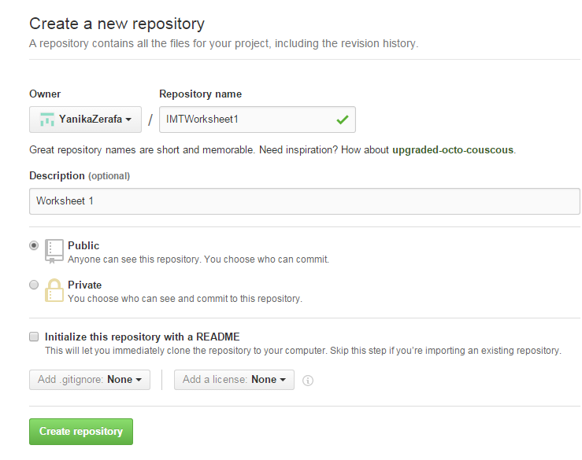

Repository

A repository is a ‘folder’ that contains files. It also stores the changes made on the files in it. Repositories can be viewed by public or can be kept private.

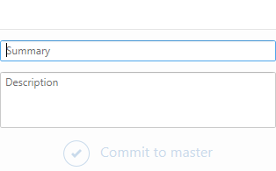

Commit

Commit means when you change something in a file and the GitHub records the change. The file is then updated upon commitment and a description of what is changed is usually kept.

Commit description

The commit description is a brief description about the changes made in a file. Every time a change is made, having a description helps to remember what is different or added.

Github desktop

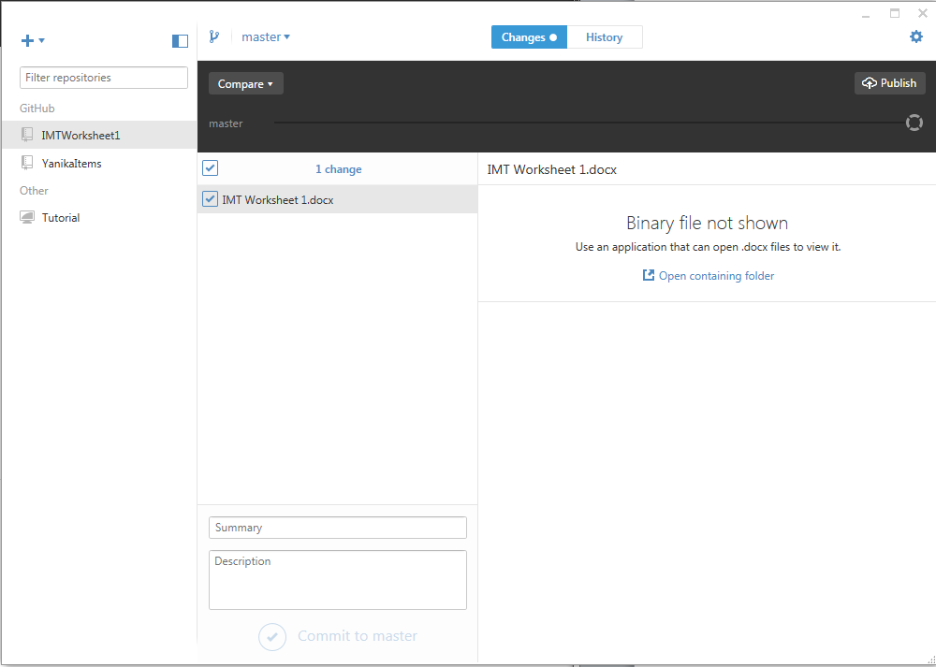Github desktop is an application that needs to be installed on the computers that you are planning to use for updating your projects. It allows you to access the files and update them.

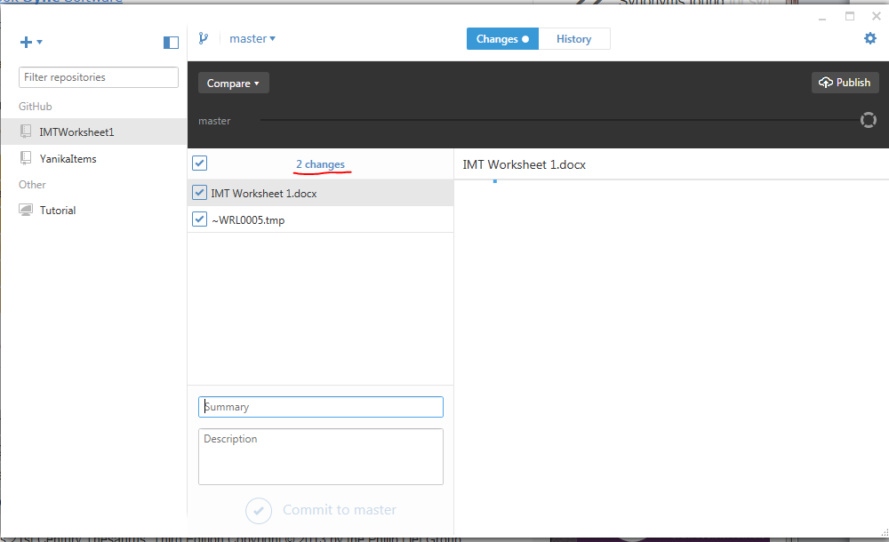

Git Sync

Git Sync is when you synchronize the files so that every update is recorded.

Downloading Zip file